Extension Activity
Kindergarten | Draw a picture of your favorite character.
First Grade | Draw a picture of your favorite scene in the book.
Second Grade  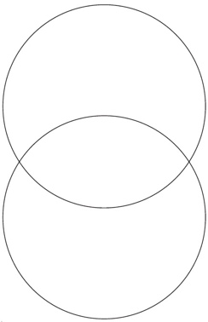 | Choose 2 books to compare. List two ways they are alike and 2 ways they are different.
Third Grade | Draw a Venn Diagram and compare the original story to a fractured one. List 3 ways they are similar and 3 ways they are different.
Fourth Grade | Who do you believe?  Write a paragraph stating WHICH POINT OF VIEW you believe. Baby Bear’s or the original and WHY?
Fifth Grade

